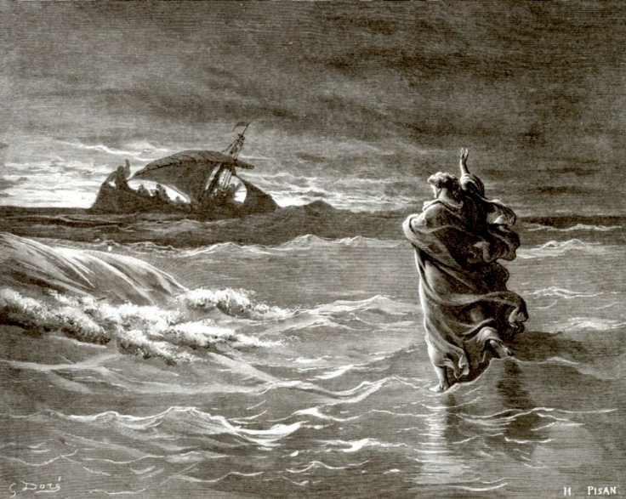
Presbyterian Church of Vinton

Seven days without prayer makes one weak.

Presbyterian Church of Vinton
Eleventh Sunday after Pentecost
“A Voice of Mission Statement:
Hope and Love to All”

Sunday, August 9, 2026 10:30 AM

Prelude Liturgist

Welcome And Announcements Liturgist
A special welcome to our online visitors

Post-VBS Video Kathy Blank

Responsive Call to Worship Psalm 105 Liturgist
O give thanks to the Lord, call on his name, make known his deeds among the peoples.
Sing to him, sing praises to him; tell of all his wonderful works.
Glory in his holy name; let the hearts of those who seek the Lord rejoice.
Seek the Lord and his strength; seek his presence continually.
Remember the wonderful works he has done, his miracles, and the judgments he uttered.
He is the Lord our God; his judgments are in all the earth. He is mindful of his covenant forever, of the word that he commanded, for a thousand generations.

*Hymn # 234 Crown Him with Many Crowns

*Call to Confession Liturgist
The deepest longing of our hearts is to be forgiven and embraced by our God. As we confess our sins, God speaks peace to us and makes us whole. Join me, as we pray together, saying,

Unison Prayer of Confession
In truth, God of Silence and Seas, we are more adept at making waves than calming storms. We find it easier to push people out of the boat, rather than make room for those who are different from us. And our lives are such a whirlwind of activity, that we do not notice your presence or hear your sheer silence singing your shalom to us. Have mercy on us, God of patience. Grab hold of us to keep us from drowning in our oceans of temptations. Give us the words to speak of your hope to others. Fill our hearts with the love of Jesus Christ, which is nearer to us than we dare to imagine.

Responsive Assurance of Pardon Liturgist
Immediately, immediately! Your sins are forgiven, your life is restored, and grace becomes your guide through this life.
Thanks be to God! We are not left alone but take heart in the forgiving love of our God. Amen

*Gloria Patri

Scripture Romans 10:5-11 Liturgist
⁵ Moses writes concerning the righteousness that comes from the law, that “the person who does these things will live by them.” ⁶ But the righteousness that comes from faith says, “Do not say in your heart, ‘Who will ascend into heaven?’” (that is, to bring Christ down) ⁷ “or ‘Who will descend into the abyss?’” (that is, to bring Christ up from the dead). ⁸ But what does it say? “The word is near you, in your mouth and in your heart” (that is, the word of faith that we proclaim), ⁹ because if you confess with your mouth that Jesus is Lord and believe in your heart that God raised him from the dead, you will be saved. ¹⁰ For one believes with the heart, leading to righteousness, and one confesses with the mouth, leading to salvation. ¹¹ The scripture says, “No one who believes in him will be put to shame.”

Scripture Matthew 14:22-33 Pastor
Jesus Walks on the Water
²² Immediately he made the disciples get into a boat and go on ahead to the other side, while he dismissed the crowds. ²³ And after he had dismissed the crowds, he went up the mountain by himself to pray. When evening came, he was there alone, ²⁴ but by this time the boat, battered by the waves, was far from the land, for the wind was against them. ²⁵ And early in the morning he came walking toward them on the sea. ²⁶ But when the disciples saw him walking on the sea, they were terrified, saying, “It is a ghost!” And they cried out in fear.
²⁷ But immediately Jesus spoke to them and said, “Take heart, it is I; do not be afraid.” ²⁸ Peter answered him, “Lord, if it is you, command me to come to you on the water.” ²⁹ He said, “Come.” So, Peter got out of the boat, started walking on the water, and came toward Jesus.
³⁰ But when he noticed the strong wind, he became frightened, and, beginning to sink, he cried out, “Lord, save me!” ³¹ Jesus immediately reached out his hand and caught him, saying to him, “You of little faith, why did you doubt?” ³² When they got into the boat, the wind ceased. ³³ And those in the boat worshiped him, saying, “Truly you are the Son of God.”

Message With Fear and Trepidation Pastor

Hymn # 42 Seek Ye First

Invitation To Offering Pastor
Offertory
Doxology

Sharing of Joys and Concerns
Pastoral Prayer: (when asking for a prayer or joy, state your name)
Responsive for Joy: Lord giving Thanks! Hear our prayer!
Responsive for Concern: Lord in your mercy! Hear our Prayer!

Lord’s Prayer
Our Father, who art in heaven, hallowed be thy name. Thy kingdom come, thy will be done, on earth as it is in heaven. Give us this day, our daily bread. And forgive us our debts, as we forgive our debtors. And lead us not into temptation but deliver us from evil. For thine is the kingdom, and the power, and the glory forever. Amen.

*Hymn # 404 The Solid Rock (vs. 1,4)

*Benediction Pastor
____________________________________
*You are invited to rise in body/spirit as you are able
Today’s Service
Pastor: Johannes Poetschner
Liturgist: Kelly Henkle
Organist: Inge Schminke
Ushers: Worship Committee

Every Sunday’s Schedule
10:30 AM Sunday Worship Service
11:30 AM Fellowship in Fellowship Hall

Presbyterian Church of Vinton
608 1st Avenue • Vinton, Iowa, 52349
Pastor Hans: phone: 217-827-3467
Church office phone: 319-472-3766
e-mail: vintonpresbyterian@gmail.com
Online at: www.vintonpresbyterian.org

Presbyterian Church of Vinton Leadership:
Pastor: Pastor Johannes Poetschner (Pastor Hans)
Elders: Nancy Baldwin, Mindy Burke, Jerry Blank, Terrie Johnson, Bonnie Peacock, Rosemary Schwartz, Angie Merchant-Stueck, Pauline Elwick and Jax Elwick.
Deacons: Marilyn Yedlik (Chr.), Jorgie Bendull, Karen Buseman, Gwen Eells, Marti Eckhart, Joan Oliphant, Ron Tippett, Dianna Wiese.
President of the Corporation: Terrie Johnson
Treasurer: Linda Druschel
Secretary: Rose Rouse


8/14 Alexander James Philip Matson
Next Sunday, August 16, 2026
Pastor: | Johannes Poetschner
Scriptures: | Isaiah 56:11-18  Matthew 15:21-28
Theme:  Liturgist: | The Call of Christ to All the Nations  Mindy Burke
Ushers: | Worship Committee

Announcements
“None of our success would be possible without generous donors like you. Thank you again for your commitment and kindness.”

Thank you to the Worship Committee for the Coffee and Treats in Fellowship Hall following our morning service.

Hand Bell practice will begin on Monday, September 14th.

2026 Per Capita: $46.63
Attendance on August 2: 31 plus 6 visitors
Zoom: (0) Facebook: (2) Views for the week: 69

This Week:
Monday, August 10 9:00 AM-12:00 PM Office closed
Tuesday, August 11 9:00 AM-11:00 AM Sewing Group
Wednesday, August 12 2:00 PM-3:00 PM Bible Study (Romans 1)

